LCA comparison of mtl.asm Box in a Box vs Ship in Own Container designed by FoamIndustries.com

Introduction
This report compares the "box in a box" style packaging to a SIOC package designed by Foam Industries. The existing package design is to put a guitar pedal into a bag, which is them placed into a small box, which is then placed in a larger shipping container with loose dunnage paper and bubble. Foam Industries designed a new package that is less expensive, better for the environment and delivers an un-paralleled un-boxing experience.

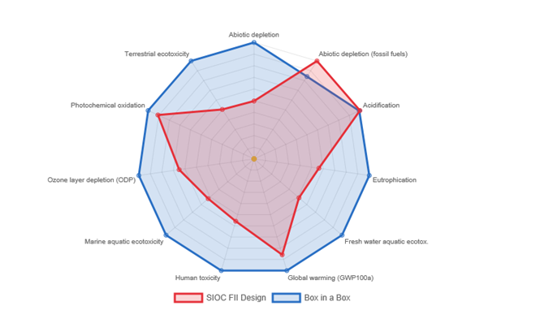

Relative Results
The following chart shows the relative indicator results of the respective project variants. For each indicator, the maximum result is set to 100% and the results of the other variants are displayed in relation to this result.

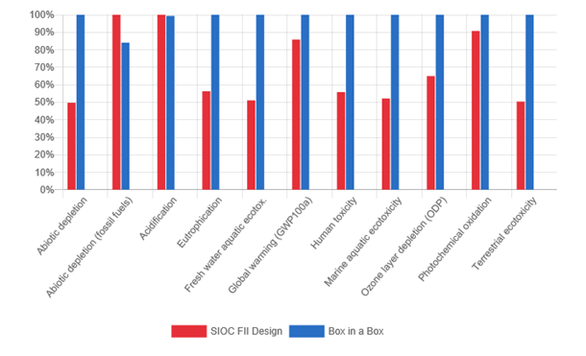
Indicator | SIOC FII Design | Box in a Box |  |  | Unit
Abiotic depletion | 1.89212e-7 | 3.80634e-7 |  |  | kg Sb eq
Abiotic depletion (fossil fuels) | 4.18175e+0 | 3.51681e+0 |  |  | MJ
Acidification | 8.98679e-4 | 8.92981e-4 |  |  | kg SO2 eq
Eutrophication | 2.83166e-4 | 5.03044e-4 |  |  | kg PO4--- eq
Fresh water aquatic ecotox. | 6.97154e-2 | 1.36521e-1 |  |  | kg 1,4-DB eq
Global warming (GWP100a) | 2.26113e-1 | 2.63432e-1 |  |  | kg CO2 eq
Human toxicity | 5.42218e-2 | 9.71423e-2 |  |  | kg 1,4-DB eq
Marine aquatic ecotoxicity | 3.12488e+2 | 5.98909e+2 |  |  | kg 1,4-DB eq
Ozone layer depletion (ODP) | 1.19458e-8 | 1.83814e-8 |  |  | kg CFC-11 eq
Photochemical oxidation | 4.70305e-5 | 5.18177e-5 |  |  | kg C2H4 eq
Terrestrial ecotoxicity | 6.05243e-4 | 1.19938e-3 |  |  | kg 1,4-DB eq

